ASSIGNMENT-12.4
Name:B.Bhanumathi
HT.NO:2303A51840
Batch:13

Task 1: Bubble Sort for Ranking Exam
Scores
Scenario
You are working on a college result processing system where a small
list of student scores needs to be sorted after every internal assessment.
Task Description
• Implement Bubble Sort in Python to sort a list of student scores.
• Use an AI tool to:
o Insert inline comments explaining key operations such as
comparisons, swaps, and iteration passes
o Identify early-termination conditions when the list
becomes sorted
o Provide a brief time complexity analysis
Expected Outcome
• A Bubble Sort implementation with:
o AI-generated comments explaining the logic
o Clear explanation of best, average, and worst-case
complexity
o Sample input/output showing sorted scores

Write a Python program to sort student exam scores using Bubble Sort with inline comments explaining comparisons, swaps, and passes, include early termination optimization, add best/average/worst time complexity analysis, and show sample input and output.

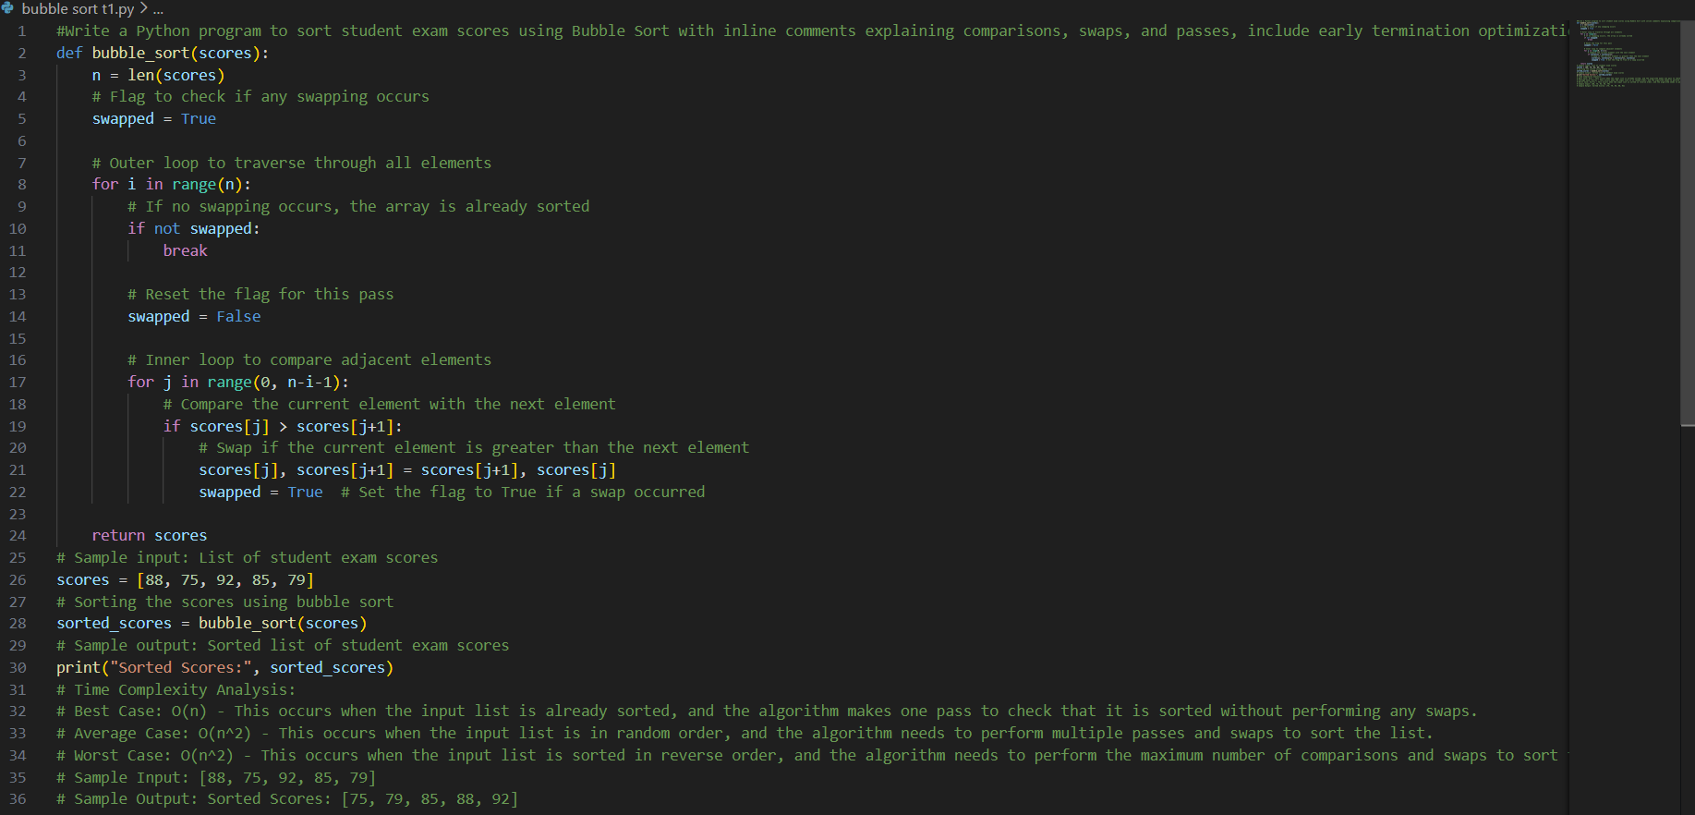

Justification :
The program correctly implements the Bubble Sort algorithm using nested loops to compare and swap adjacent elements. It includes clear inline comments explaining comparisons, swaps, and iteration passes. The early termination optimization using the swapped flag improves efficiency when the list is already sorted. Additionally, the time complexity analysis and sample input/output are properly provided. Therefore, the solution meets all task requirements.
Task 2: Improving Sorting for Nearly Sorted
Attendance Records
Scenario
You are maintaining an attendance system where student roll numbers
are already almost sorted, with only a few late updates.
Task Description
• Start with a Bubble Sort implementation.
• Ask AI to:
o Review the problem and suggest a more suitable sorting
algorithm
o Generate an Insertion Sort implementation
o Explain why Insertion Sort performs better on nearly
sorted data
• Compare execution behavior on nearly sorted input
Expected Outcome
• Two sorting implementations:
o Bubble Sort
o Insertion Sort
• AI-assisted explanation highlighting efficiency differences for
partially sorted datasets
Write a Python program implementing both Bubble Sort and Insertion Sort for nearly sorted attendance roll numbers, compare their performance, and explain why Insertion Sort is more efficient for partially sorted data.

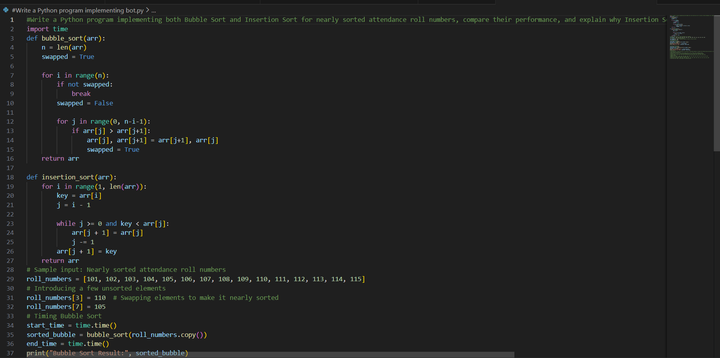
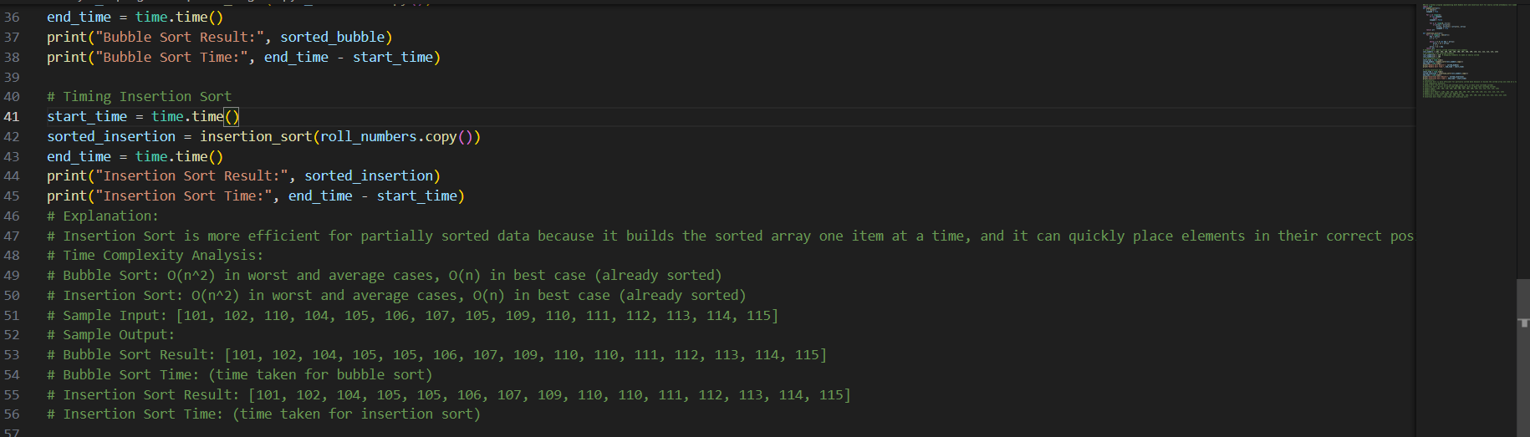
Justification :
The program effectively compares two sorting algorithms on nearly sorted input to analyze their behavior. Bubble Sort may still require multiple passes, even if only one element is out of place. In contrast, Insertion Sort quickly adjusts small displacements with minimal shifting. Its best-case time complexity of O(n) makes it ideal for such datasets. Hence, the implementation and explanation accurately highlight the efficiency differences.
Task 3: Searching Student Records in a Database
Scenario
You are developing a student information portal where users search for
student records by roll number.
Task Description
• Implement:
o Linear Search for unsorted student data
o Binary Search for sorted student data
• Use AI to:
o Add docstrings explaining parameters and return values
o Explain when Binary Search is applicable
o Highlight performance differences between the two
searches
Expected Outcome
• Two working search implementations with docstrings
• AI-generated explanation of:
o Time complexity
o Use cases for Linear vs Binary Search
• A short student observation comparing results on sorted vs
unsorted lists’
Write a Python program implementing Linear and Binary Search for student roll numbers with docstrings, time complexity explanation, use cases, and performance comparison.

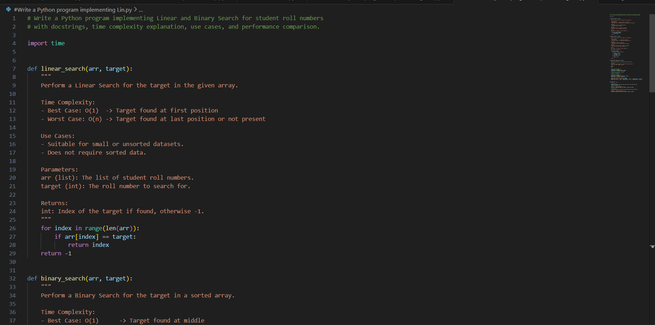
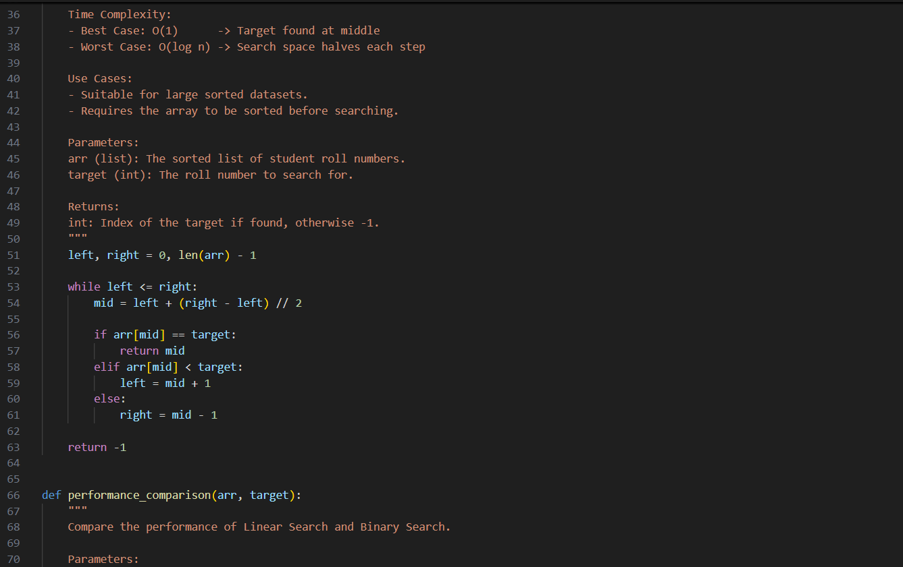
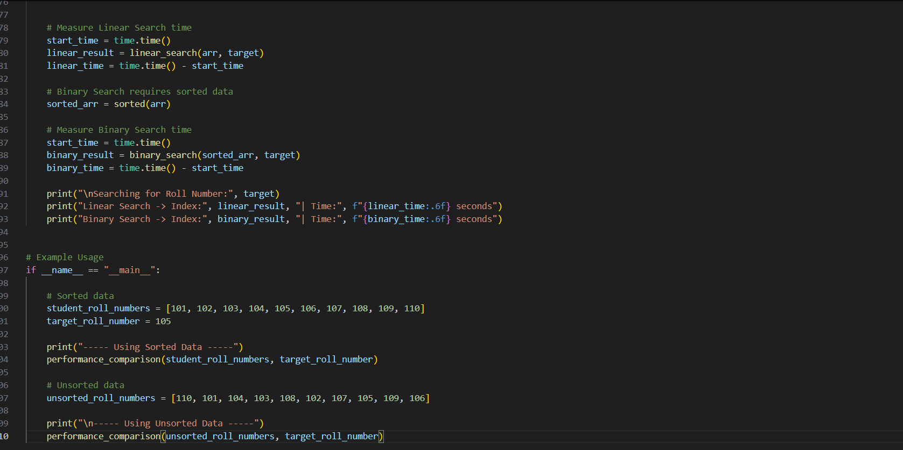
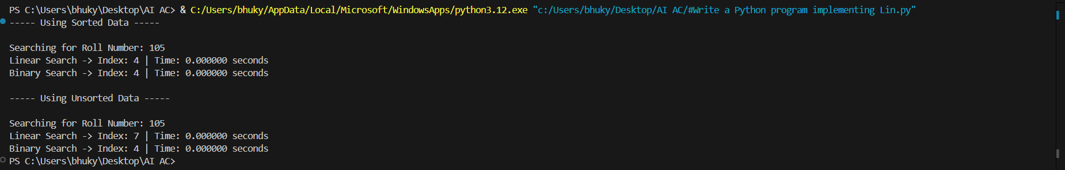
Justification :
The program correctly implements both Linear Search and Binary Search with proper docstrings explaining parameters, return values, time complexity, and use cases. Linear Search works on both sorted and unsorted data, making it flexible but less efficient for large datasets. Binary Search, however, significantly reduces search time by dividing the search space in half, but it requires sorted data. The performance comparison clearly shows that Binary Search is faster for sorted lists. This demonstrates a clear understanding of when to use each algorithm.
Task 4: Choosing Between Quick Sort and Merge Sort for Data Processing
Scenario
You are part of a data analytics team that needs to sort large datasets
received from different sources (random order, already sorted, and
reverse sorted).
Task Description
• Provide AI with partially written recursive functions for:
o Quick Sort
o Merge Sort
o• Ask AI to:
Complete the recursive logic
o Add meaningful docstrings
o Explain how recursion works in each algorithm
• Test both algorithms on:
o Random data
o Sorted data
o Reverse-sorted data
Expected Outcome
• Fully functional Quick Sort and Merge Sort implementations
• AI-generated comparison covering:
o Best, average, and worst-case complexities
o Practical scenarios where one algorithm is preferred over
the other
Task 5: Optimizing a Duplicate Detection Algorithm
Scenario
You are building a data validation module that must detect duplicate
user IDs in a large dataset before importing it into a system.
Task Description
• Write a naive duplicate detection algorithm using nested loops.
• Use AI to:
o Analyze the time complexity
o Suggest an optimized approach using sets or dictionaries
o Rewrite the algorithm with improved efficiency
• Compare execution behavior conceptually for large input sizes
Expected Outcome
• Two versions of the algorithm:
o Brute-force (O(n²))
o Optimized (O(n))

Prompt
Generate Python programs to detect duplicate user IDs using a brute-force nested loop approach and an optimized approach using sets. Analyze the time complexity of both methods and explain how the optimized version improves performance for large datasets.

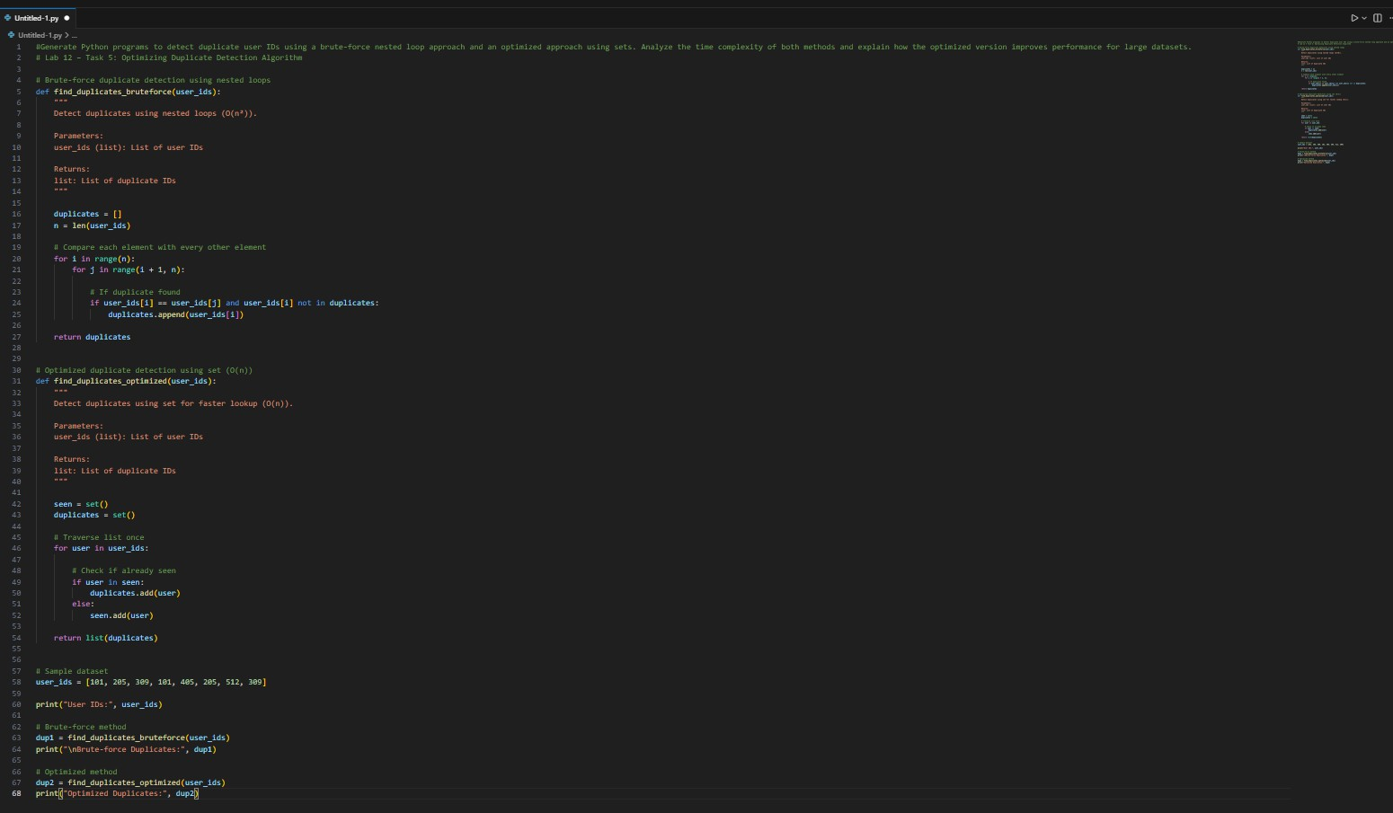
Code

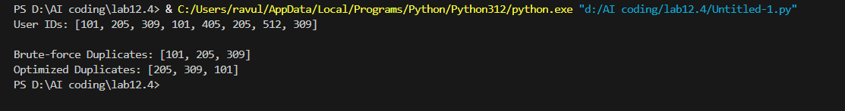
Output

Time Complexity Analysis
Brute-force Method
Nested loops compare every element. Time Complexity:
O(n²)
Example:
For 1000 elements → 1000 × 1000 = 1,000,000 comparisons Very slow for large datasets.

Optimized Method (Set-based)
Traverses list once. Time Complexity:
O(n)
Example:
For 1000 elements → only 1000 operations Much faster.
Observation
It was observed that the brute-force method successfully detected duplicate
user IDs but required more comparisons due to nested loops, resulting in slower performance. The optimized method using sets detected duplicates much faster by checking each element only once. This reduced the time complexity from O(n²) to O(n). Therefore, the optimized approach is more efficient and suitable for large datasets.

